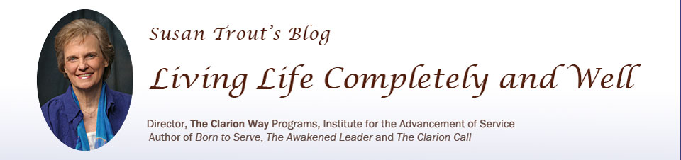

Adding Light to the World: An Urgent Call

We had forgotten who we are
And why we had come
A clarion blast
Awakens us to our injured world
Together we answer an urgent call
To add Light to the world
~ Susan S. Trout ~

A crisis of epidemic proportions blankets the world. Devastating natural disasters, wars between nations, financial uncertainty, misused technology, political disturbances, terrorism, and threats of global destruction shatter our reality. As the chaos of our world intensifies, we search for ways to help and bring love, care, and compassion into the world, wondering:
What is the greatest need in our world today? How do we connect with our inner strength? What is the highest service we can extend to humanity? The answer to these questions is clear:
- The greatest need in today’s world is that it needs more Light.
- We experience inner strength when we connect to the Sacred Within and trust our willingness and ability to be a Force of Light.
- Our highest service to humanity is to breathe Light into the world.

The Gift of the Hamsa Mantra

The Hamsa mantra is a balance between the outbreath and inbreath of God. Our inbreath is from God; our outbreath (from God) adds to the Light of the world. We thereby extend God’s Life Force into the world, serving the highest good of humanity and the planet. This is true for every breath we take.

Hamsa means I am That – That I am. “I” is individual self-awareness. “That” is the unlimited consciousness of the Universal Self, also referred to as the I AM Presence, Divine Source, God Within, Father-Mother God, Unknowable Absolute, and Life Force. The Hamsa mantra affirms our connection with the Divine and thereby supports our remembering that we are not alone.

The Hamsa mantra (also called the natural or prana mantra) goes on continually in all living creatures. It is due to the Hamsa mantra pulsation that we are alive. In a human being, the breath comes in and goes out 21,600 times a day, and each time it repeats this mantra. This process goes on continuously day and night in a living being – Ham on the inbreath, sa on the outbreath – again and again: Ham-sa... Ham-sa…

In real time, we add to the Light of the world and thereby reflect back to God our gift of life. By adjusting our awareness about every breath we take, no matter where we are or what we are doing, thinking, or feeling, we add Light to the world. With our outbreath, we ask that every thought, feeling, and deed be consecrated with Divine Love for the purpose of adding to the Light of the world every minute of every day. In this process, we become Lightbearers, those who show another way – a way to learn, grow, and serve with love and compassion.

Hamsa Mantra Meditation Practice

Acknowledge trust in your ability to be a Force of Light by affirming from your heart: “I breathe in the Light of God. I breathe out God’s Light to the World.”

Hamsa mantra meditation is a simple technique of quietly watching the breath come in and go out, without doing anything else. As the breath comes in, it makes the sound Ham (pronounced as h-ah-m), meaning I breathe in the Light of God. As the breath goes out, it makes the sound sa (pronounced s-ah), meaning I breathe out God’s Light to the World.

Sit upright with your feet on the floor or in a cross-legged position on the floor or in a chair. Join the index finger and thumb of each hand and rest your hands on your knees. Keep your spine straight and comfortable.

Close your eyes. Breathe naturally.

Repeat the mantra silently. Ham on the in-breath, sa on the out-breath.

Concentrate on the mantra. Become absorbed in it. Move into meditation, bringing your attention back to the mantra when you are distracted by thoughts, feelings, or noises.

Meditate for 20 minutes or for a period of time that is comfortable for you.

Note: The secret of the Hamsa was first revealed in the great Kashmir Shaivism treatise, the Vijnana Bhairava.

Reflection

Journal thoughts and feelings that arise as you contemplate this teaching:

Our highest service to humanity is to breathe
Light into the world.

We had forgotten who we are
And why we had come
A clarion blast
Awakens us to our injured world
Together we answer an urgent call
To add Light to the world
~ Susan S. Trout ~

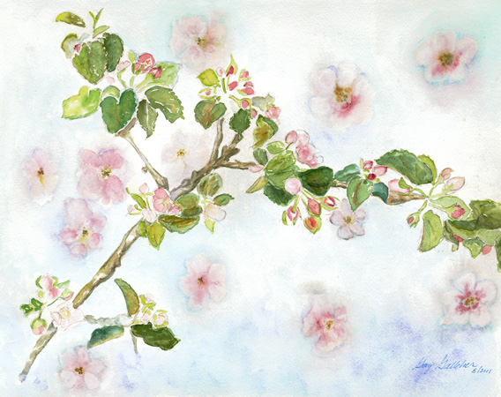
It's Apple Blossom Time © by Gay Gallaher
(for purchase, visit www.gaygalleherarts.com)

Source: Susan Trout’s Blog: Living Life Completely and Well, www.susantroutsblog.com, © Susan S. Trout, PhD, Institute for the Advancement of Service (www.ias-online.org), September 2017.

